# PROCEDURE TO CREATE CLOUDANT-DB

* To create a DatabaSE USING IBM cloudant

service

**Step 1:** Open the IBM cloud website. In the Resource list page, under Services click Cloudant-g4.You’ll be redirected to a new page, click Launch Dashboard.

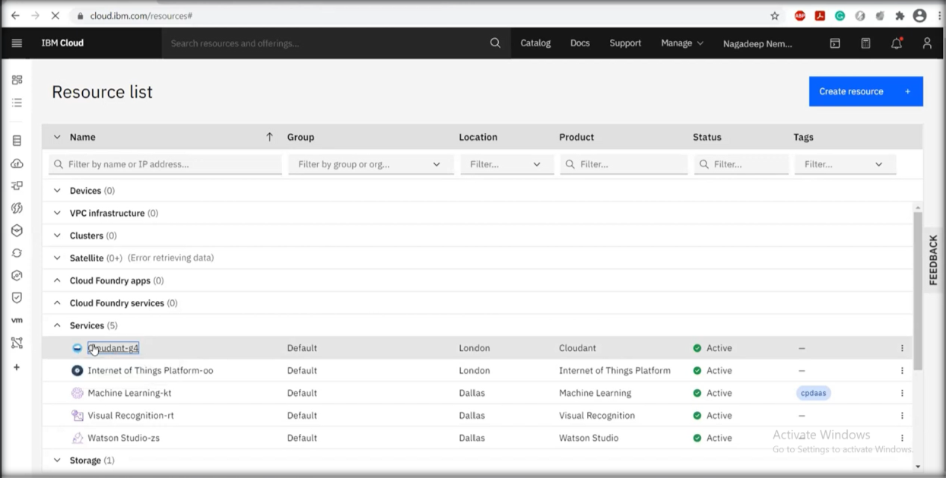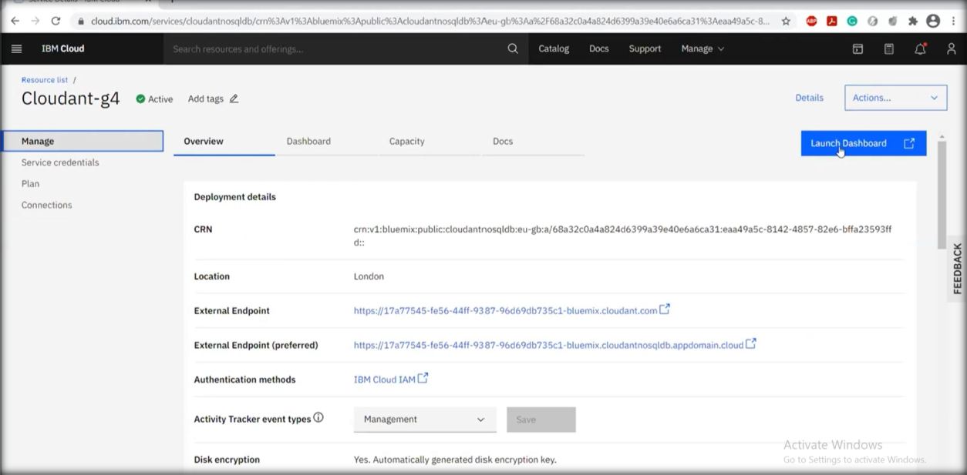

**Step 2:** You’ll be redirected to databases page. Provide a database name and select partitioned and then select create. Then click

create document.

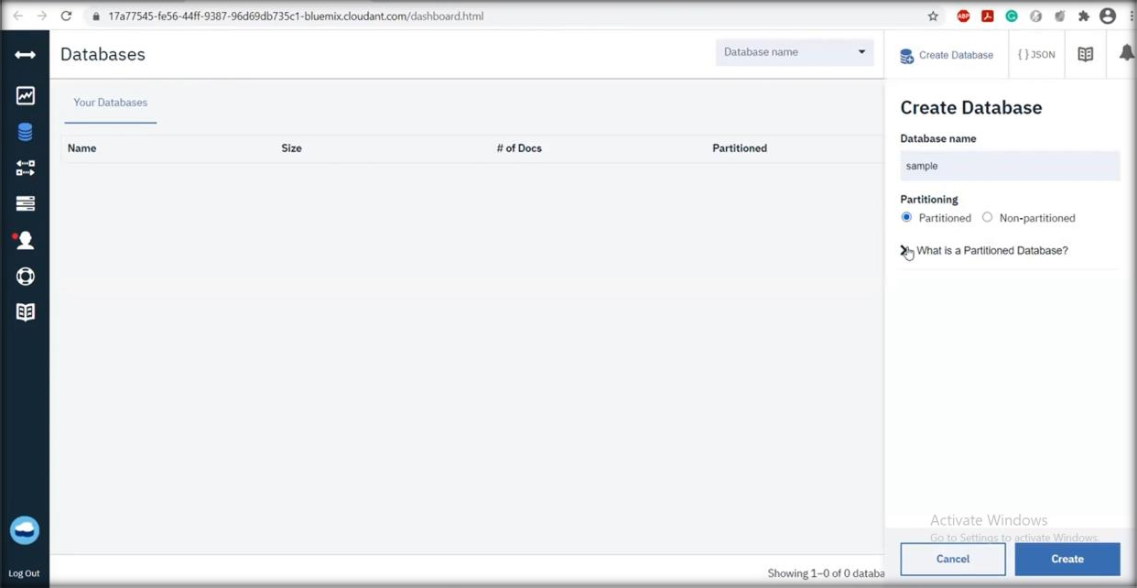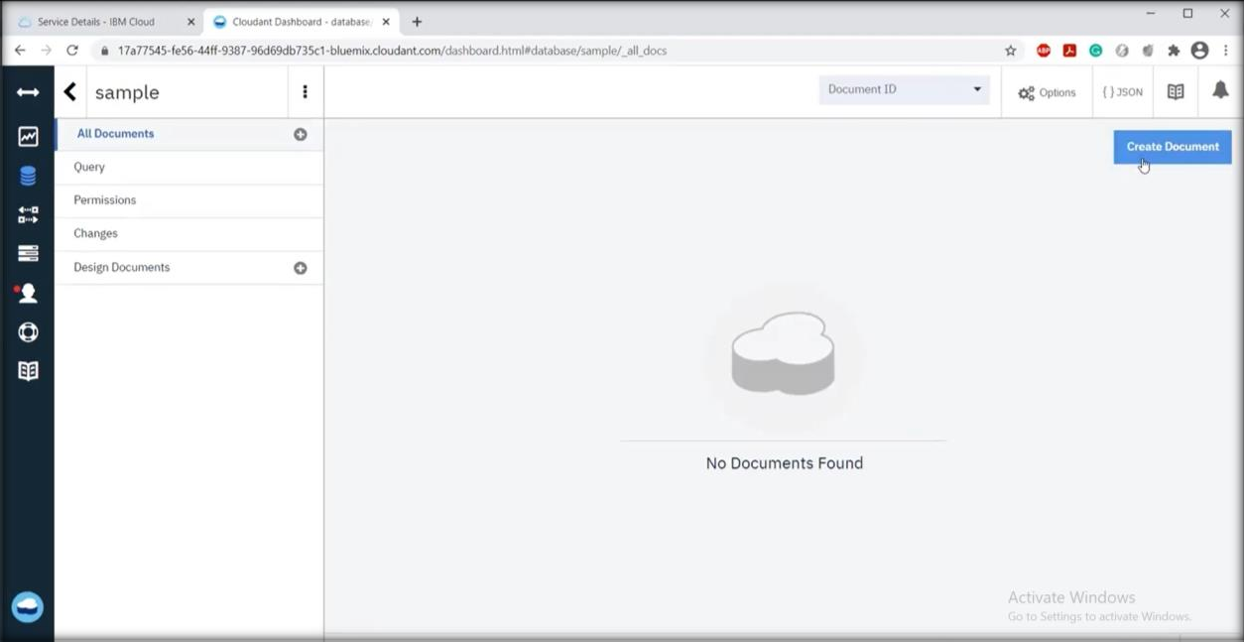

**Step 3:** A new page will appear with id. Enter your database and

create.

